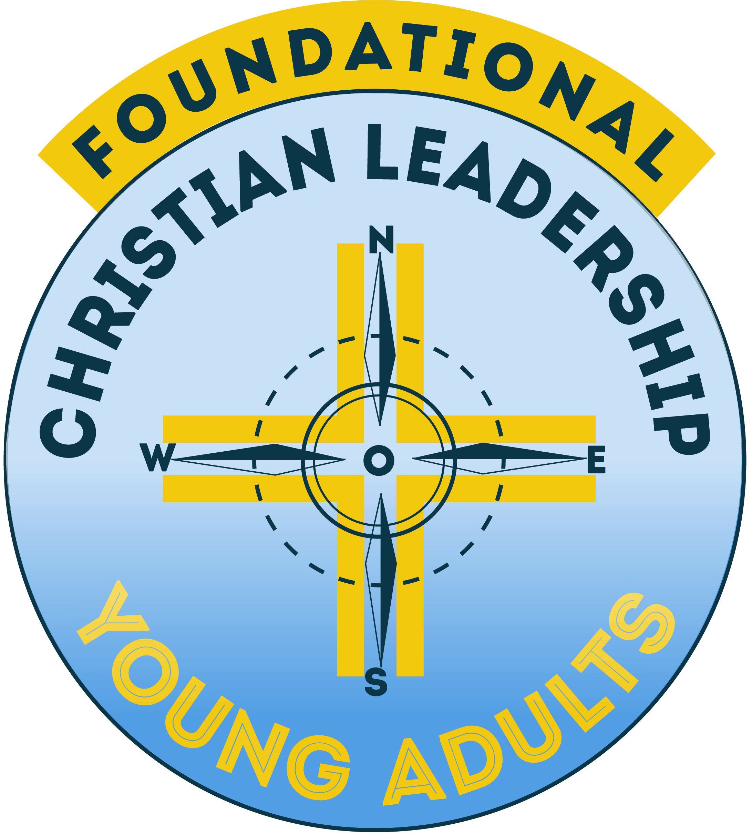
September 2017
Information on Foundational Leadership Programme for Young Adults 2016
Parishes within the Archdiocese are invited to identify and nominate at least one young adult to participate on our Foundational Leadership Programme for Young Adults. This course has been run previously and resulted in many graduates taking up positions of leadership in their parish, in the diocese and at World Youth Day.
Many parishes often discuss the problems of creating, developing and sustaining youth ministry programmes and encounter the real challenges faced when attempting to reach out to young people in the parish. This course is designed to support young adults and in turn, their parishes. It is a dynamic, integrative and highly practical programme which will enable the participants to begin developing their skills as leaders and role models within their local faith based communities.
Pope Francis reminds us that “young people are the windows through which we see the future” and the local parish is the seed bed for these young people to discover and grow in faith. He also challenged young people at WYD to “get off the couch”. Hopefully this course will do that.
I urge you to highlight this vital and hopefully identify and sponsor some local young adults. If your parish had young adults represented at WYD – this is an ideal follow up.
I also invite you to ensure it is promoted locally on websites, notices, social media and even a personal invitation might work. More information is available on www.evangelisation.ie
We hope that all pastoral areas and deaneries will have strong young adult representation.
Feel free to contact if you have any queries.

Gerard Gallagher
Office for Evangelisation and Ecumenism,
Holy Cross Diocesan Centre,
Clonliffe Road,
Dublin3.
01-8373732 ex 242 / 087-2347220
ggallagher@abhouse.org

